### 02). Organize and play games to understand the agile process like, Morning wake up game.

**A) The Marshmallow Challenges:**

The marshmallow challenge was introduced by Tom Wujec. The Purpose of the challenge is to build the Team Coordination, team Work, Patience, Communication and Time Management.

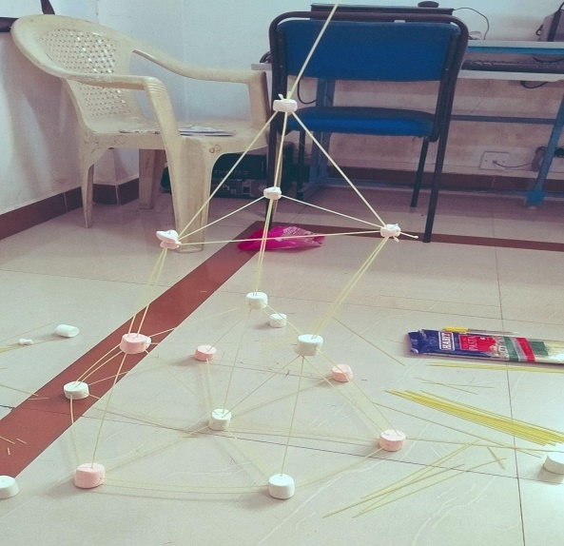

**Objectives:**

The goal is to build a freestanding structure using limited materials that can hold a marshmallow without it falling.

**Requirement Needed for this Challenge Was:**

**a.**20 sticks of spaghetti

**b.**8 Marsh Mallow

* Build the tallest Free-standing Structure in just 18 minutes using no more than 20 sticks of Spaghetti. one yard of String, and 08 Marsh Mallow.
* The structure has to stand firmly on its own, it cannot be propped upTeams cannot hold on to the

Structure when the time runs out. Those touching or supporting the Structure at the end of the exercise will be disqualified.

* The Marshmallow Challenge is a fun and engaging way to build teamwork and problem-solving skills. It's an excellent exercise for corporate teams, students, and anyone looking to boost their collaboration and creativity skills.